Chapter 8, Problem 67.

In the op amp circuit of Fig. 8.112, determine v_{o}(t) for t > 0. Let v_{in} = u(t) V,
R₁ = R₂ = 10 kΩ, C₁ = C₂ = 100 μF.

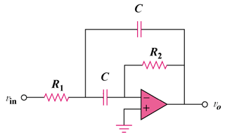

Figure 8.112
For Prob. 8.67.

